Data Structure

pset13. step1-DFS Warming up

21600124 김우빈

# Task

Create an **antenna.txt** such that it generates the adjacent list as shown.

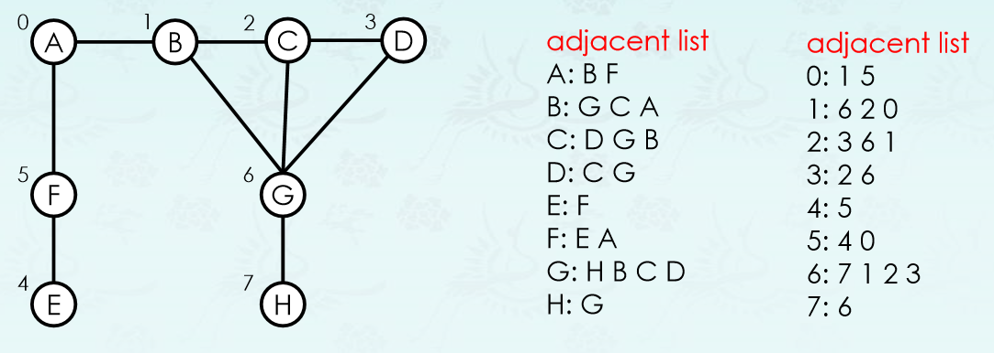

#Solution

* Process of obtaining DFS & DFS parent

|  |  |
| --- | --- |
| Process of obtaining DFS Sequence | Parent DFS |
| DFS(A) | A’s parent = -1 |
| DFS(B) | B’s parent = A(0) |
| DFS(G) | G’s parent = B(1) |
| DFS(H) | H’s parent = G(6) |
| Check G |  |
| H Done |  |
| Check B |  |
| DFS(C) | C’s parent = G(6) |
| DFS(D) | D’s parent = C(2) |
| Check C |  |
| Check G |  |
| D Done |  |
| Check G |  |
| Check B |  |
| C Done |  |
| Check D |  |
| G Done |  |
| Check C |  |
| Check A |  |
| B Done |  |
| DFS(F) | F’s parent = A(0) |
| DFS(E) | E’s parent = F(5) |
| Check F |  |
| E Done |  |
| Check A |  |
| F Done |  |
| A Done |  |

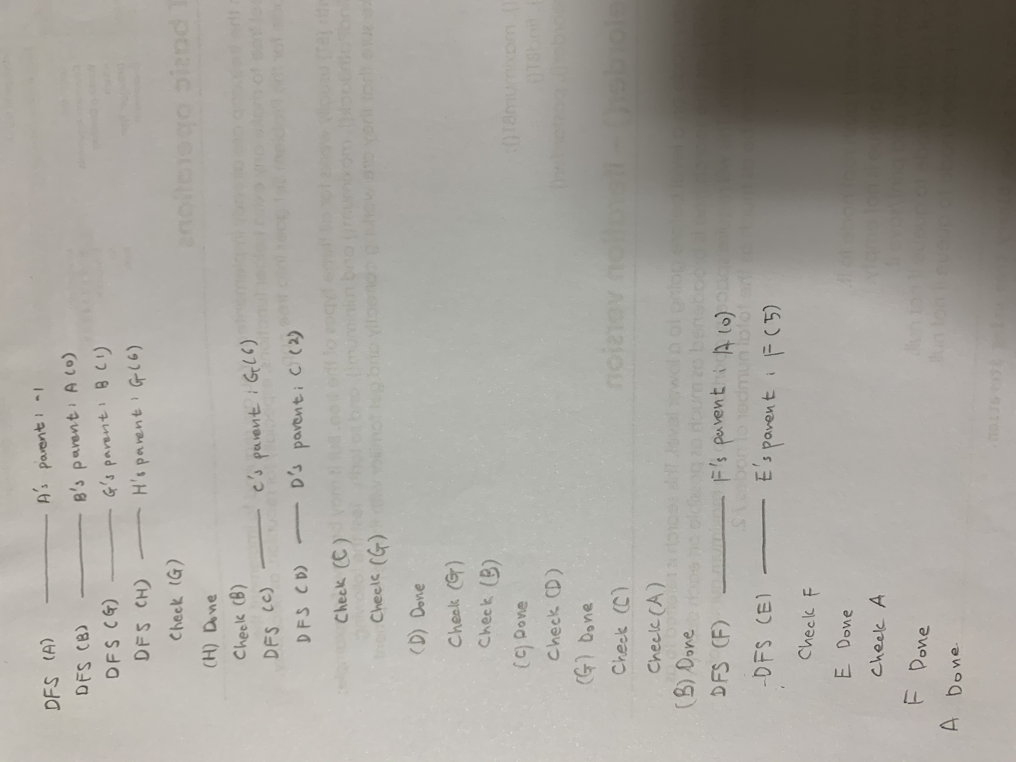

* Process of obtaining BFS & BFS parent

|  |  |  |
| --- | --- | --- |
| Process of obtaining  BFS Sequence | Queue Status | Parent BFS / Dist |
| Enqueue (A) / BFS (A) | A | A’s parent = -1 / 0 |
| Dequeue (A) |  |  |
| Check (B) |  |  |
| Enqueue (B) / BFS (B) | B | B’s parent = A(0) / 1 |
| Check (F) |  |  |
| Enqueue (F) / BFS (F) | B F | F’s parent = A(0) / 1 |
| (A) Done |  |  |
| Dequeue (B) | F |  |
| Check (G) |  |  |
| Enqueue (G) / BFS (G) | F G | G’s parent = B(1) / 2 |
| Check (C) |  |  |
| Enqueue (C) / BFS (C) | F G C | C’s parent = B(1) / 2 |
| Check (A) |  |  |
| (B) Done |  |  |
| Dequeue (F) | G C |  |
| Check (E) |  |  |
| Enqueue (E) / BFS (E) | G C E | E’s parent = F(5) / 2 |
| Check (A) |  |  |
| (F) Done |  |  |
| Dequeue (G) | C E |  |
| Check (H) |  |  |
| Enqueue (H) / BFS (H) | C E H | H’s parent = G(6) / 3 |
| Check (B) |  |  |
| Check (C) |  |  |
| Check (D) |  |  |
| Enqueue (D) / BFS (D) | C E H D | D’s parent = G(6) / 3 |
| (G) Done |  |  |
| Dequeue (C) | E H D |  |
| Check (D) |  |  |
| Check (G) |  |  |
| Check (B) |  |  |
| (C) Done |  |  |
| Dequeue (E) | H D |  |
| Check (F) |  |  |
| (E) Done |  |  |
| Dequeue (H) | D |  |
| Check (G) |  |  |
| (H) Done |  |  |
| Dequeue (D) |  |  |
| Check (C) |  |  |
| Check (G) |  |  |
| (D) Done |  |  |

